# Project _02 Report

**Objective:**

* The goal of this report is to analyze the marketing campaign performance using the provided dataset. This report visualize important data to understand spending behavior, campaign effectiveness.

**Data Overview:**

* **Dataset:** Marketing campaign dataset
* **Features:**
  + **Customer Demographics:** ID, Year_Birth, Education, Marital_Status
  + **Spending and Purchases:** MntWines, MntFruits, MntMeatProducts, MntGoldProdsand, MntSweetProducts and MntFishProducts.
  + **Marketing Interactions:** AcceptedCmp1-5, Response, Complain
  + **Miscellaneous:** Income, Recency, NumWebVisitsMonth, Z_CostContact, Z_Revenue

### ****Data Summary****

* **Total Records:** 2,240 customer records
* **Key Demographics:**
  + **Education Levels:** Qualification level, impacting purchasing behavior.
  + **Marital Status:** Various statuses analyzed for behavioral differences.
* **Key Metrics:**
  + **Total Income Analyzed:** $116M
  + **Total Z_CostContact:** 6,720
  + **Total Z_Revenue:** $25K

**Key Findings and Analysis**

**Education Impact:**

* + The dashboard used an **education filter** to understand its impact on spending and campaign acceptance.
  + **Observation:** Higher education levels tend to correlate with increased spending on products.

**Marital Status:**

* + Analyzed with education to explore spending patterns.
  + **Observation:** Married customers showed a tendency to spend more on family-oriented products.

**Income vs. Spending:**

* + A scatter plot was used to show the relationship between **income** and **spending**.
  + **Observation:** Higher-income customers tend to spend more on Purchasing Products

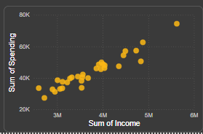

**Spending Purchases:**

* + Pie charts sows distribution across different product categories and purchase channels.
  + **Observation:** The majority of purchases occur by Store visit and rate is 28%

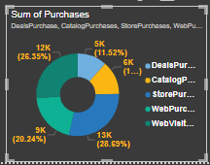

**Campaign Acceptance:**

* + Analyzed which campaigns were more successful using acceptance metrics.
  + **Observation:** Campaigns 3,4 and 5 showed the highest acceptance rates, suggesting a preference for specific promotional strategies. It shows that how positively impact the particular strategy in campiagn

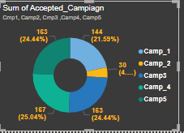

**Recency and Revenue Relationship:**

* + **Observation:** Customers with more recent interactions generated higher revenue, and it shows the importance of regular engagement.

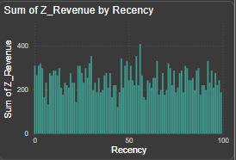

**Cost vs. Revenue:**

* The line chart compared **Z_CostContact** and **Z_Revenue** according to day.
* **Observation:** this analyze shows a positive relation with z_revenue and Z_costContact , certain days has revenue high which indicate successful campiagn implement.
  + Pattren of sales high on certain days like 7,12,17,22and 23
  + 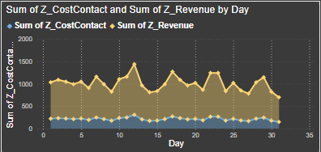

**Dashborad on Marketing Campaign**

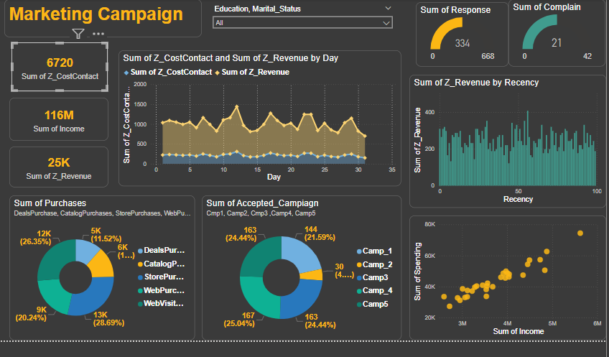

**Result After Filter**

1. When Education(Graduate) results are

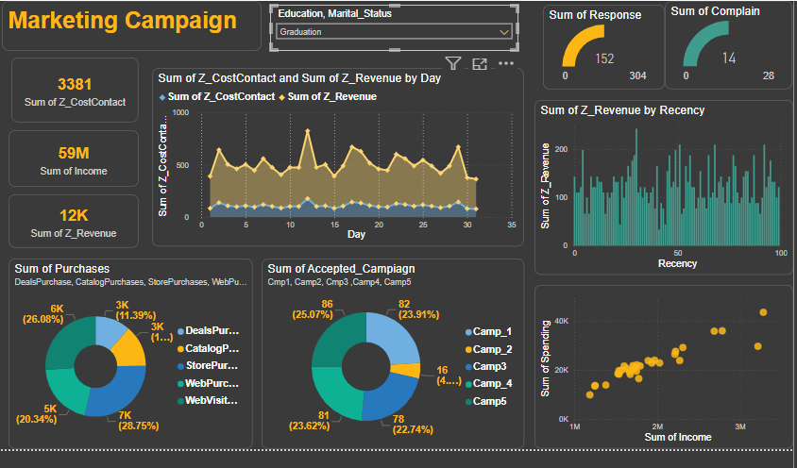

1. When Education(Basic) results are

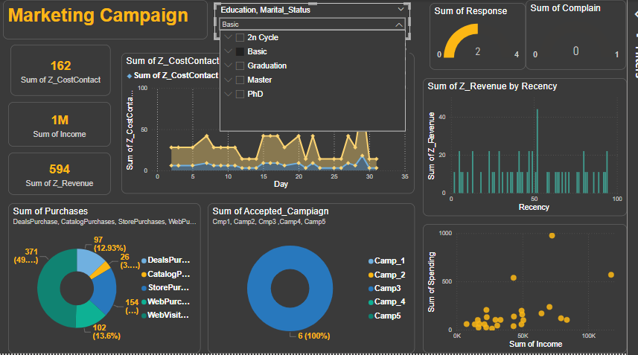

Relation between spending and income is not positivly related and response is not so good